Singly LinkedList: getIndex() and indexOf()

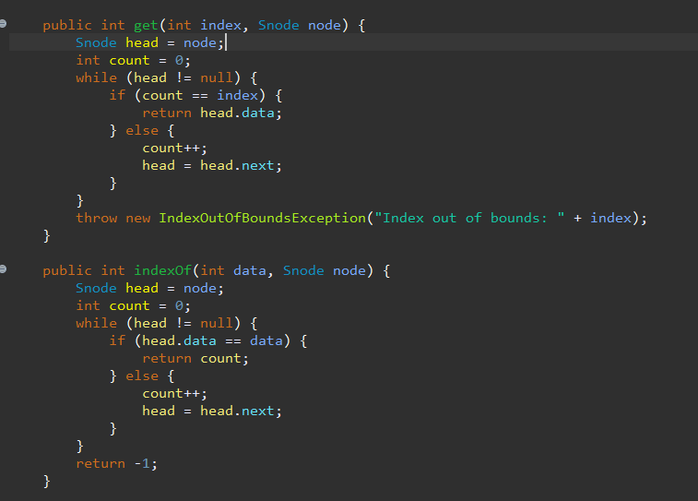

Doubly linkedList: getIndex() & indexOf()

